Screenshots

Article
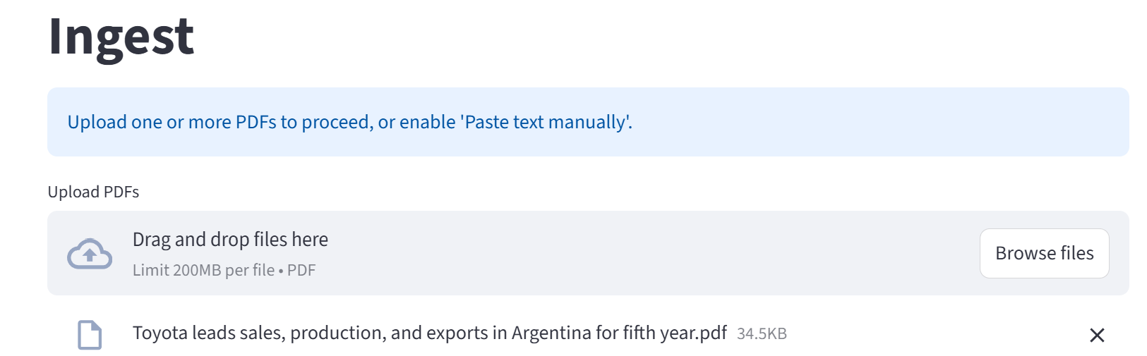

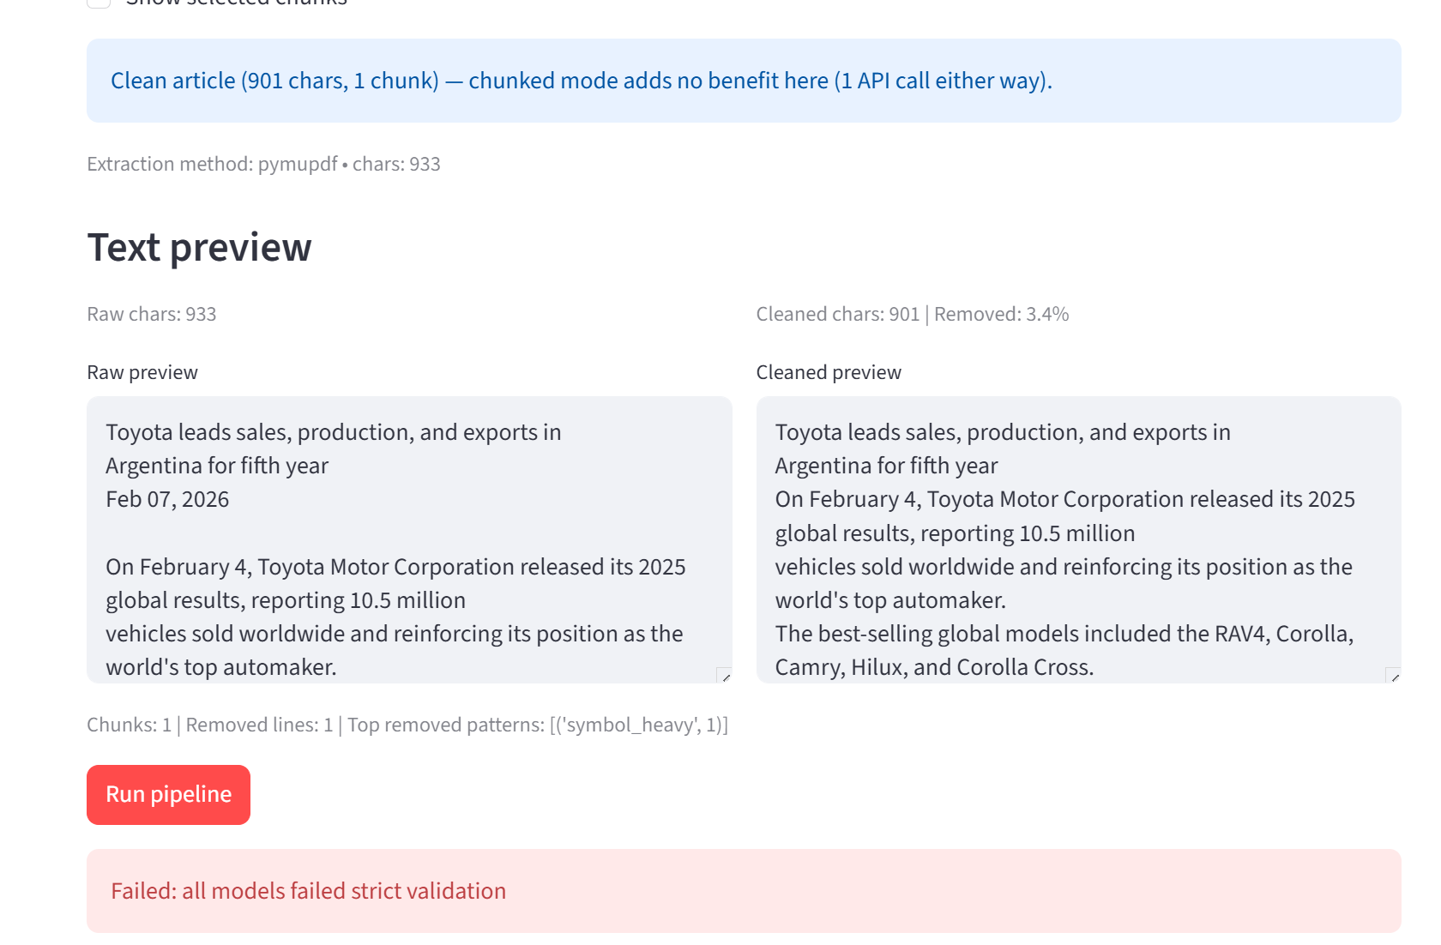
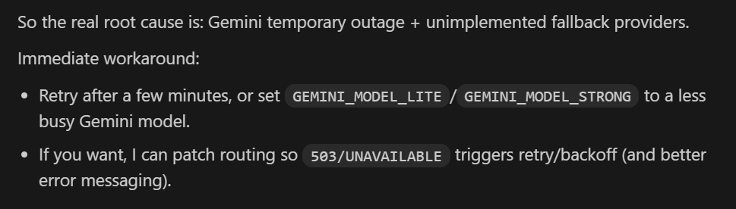

Difficulties to have correct publishing date on this type of articles:
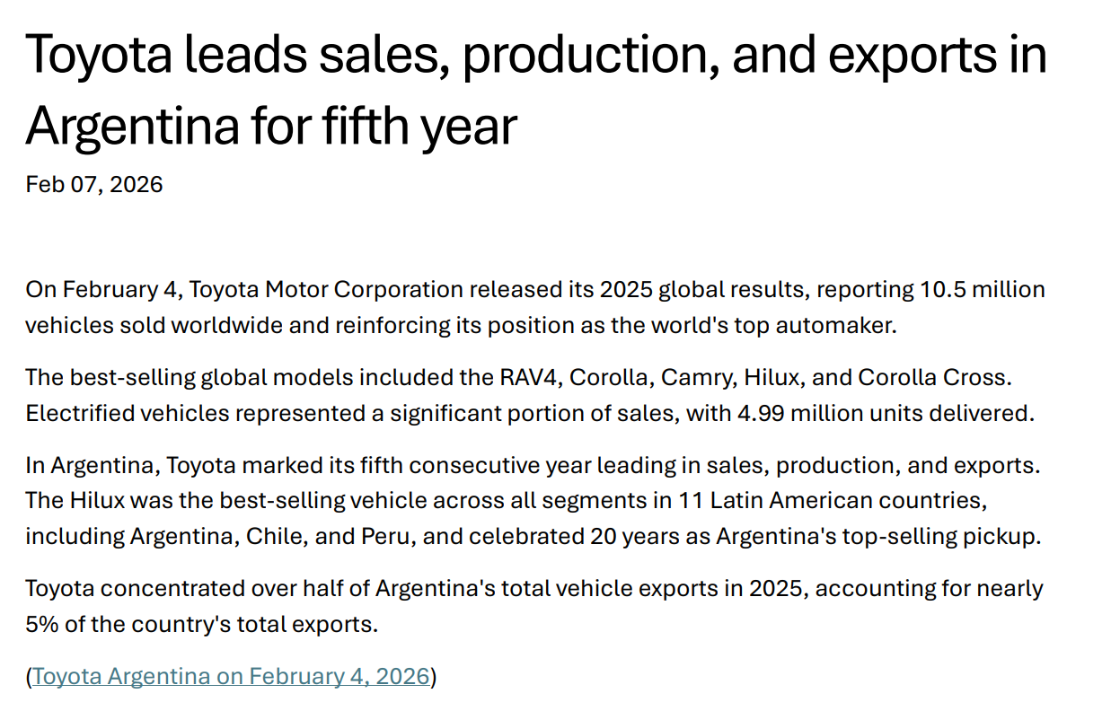

- publish_date is likely wrong
- Your JSON: 2026-02-04
- The PDF header shows: Feb 07, 2026
- The content says Toyota Argentina release was Feb 4, 2026, but that’s the release date inside the article, not necessarily the publish date of the article/PDF.
Impact: timeline accuracy, weekly rollups, and “what happened this week” logic can drift.
Fix suggestion: store both:
- publish_date = document publish date (Feb 7, 2026)
- event_date (new field) or encode in evidence bullets: “Toyota Argentina release Feb 4, 2026”
2. regions_mentioned is incorrect (set to ["US"])
Your _mutations show it changed from ["Latin America"] → ["US"]. But the PDF is clearly Argentina + Latin America (Argentina, Chile, Peru mentioned) and no US mention.
Toyota leads sales, production,…
Impact (big):
- Wrong “footprint region signals”
- Macro-theme detector falsely matches “Tariff & Trade Disruption” only because US appears
- regions_relevant_to_kiekert stays empty when it should probably include Latin America (if that’s a region bucket you support) or at least not US-derived
Fix suggestion (rule-level):
- If country_mentions contains Argentina, force regions_mentioned to include Latin America (or your canonical bucket), and never map LatAm → US.
- Add a validation: if regions_mentioned contains US but neither “United States/US” appears in text nor country_mentions includes US, flag for review.
With codex:
I fixed PDF date handling so publish_date now uses the document’s visible header date first, and only uses PDF metadata if no header date is found.
I also wired this into ingest/postprocess, and when this override replaces an internal article date, that old date is saved as event_date (instead of being lost).
Added regression tests for Toyota Argentina to ensure:
- publish_date == 2026-02-07
- internal release date remains represented (event_date == 2026-02-04)
- evidence still contains “Toyota release Feb 4, 2026”.
- I fixed region mapping so LatAm countries (including Argentina) map to Latin America instead of US.
I added a guard that removes US from regions_mentioned unless U.S. evidence exists in source text or country_mentions includes United States.
I also added a Toyota Argentina regression test to ensure:
- regions_mentioned includes Latin America
- regions_mentioned does not include US.

Rerun ingest
So if key_insights changed, it’s most likely from a new model extraction run (LLM output variability / different retry path), not from a postprocess rule rewriting key_insights.

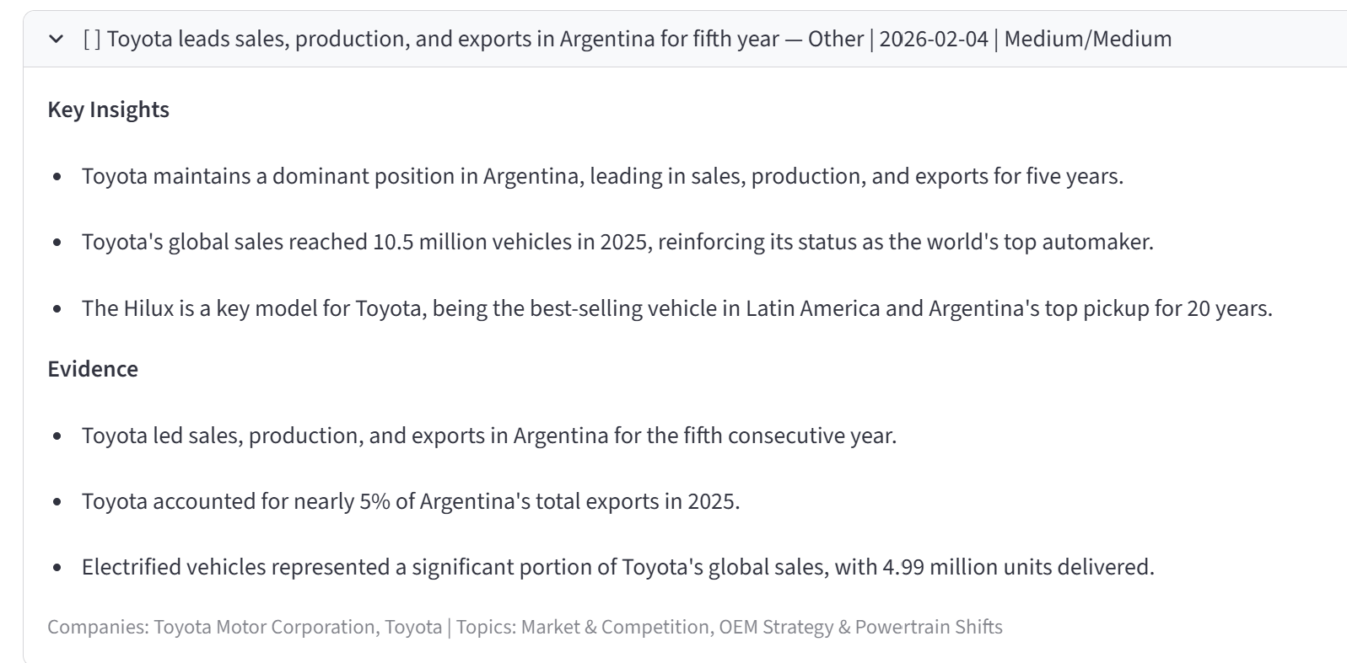

After fix:
Schema relaxation due to missing
Schema constraints that force data loss
- topics max=3 — complex articles covering 4+ topics are forced to drop some
- keywords min=5, max=12 — simple articles pad to 5; rich articles truncate at 12
- source_type — "Other" is a catch-all for WSJ, FT, industry pubs, etc. (no quality differentiation)
- actor_type — only 4 values; tech companies (Nvidia, Qualcomm) all lumped into "other"
ON GOING

